**Task 3**

**Name: Mahmoud Mohamed Hassan.**

**School: WE of Applied Technology Suez School.**

**Class: 3/3**

**Department: Programming.**

**Date: 12/12/2024**

**Content**

1. **Introduction**
2. **Design**
3. **Sharing & Feedback**
4. **Identifying improvements & apply it**
5. **Documentation**

**Introduction**

Berimbolo Security is a company specializes in providing integrated security solutions to individuals and businesses. The company aims to protect the property of its customers and ensure their safety through the use of the latest technology in the field of security and surveillance systems. Its core services include:

Security risk assessment: a comprehensive analysis of security risks and the proposal of customized solutions. Sale and installation of alarm systems and surveillance cameras: Providing advanced devices that are professionally installed. continuous monitoring: Providing permanent monitoring services that ensure a rapid response to any emergency.

**Project Objectives**

In light of the increasing demand for the company's services, Berimbolo Security seeks to improve its digital presence by designing a modern website that meets customer needs and reflects the evolution of its services. The project aims to:

New Website Design:

Provide clear and comprehensive information about services and products.

Facilitate customer communication with the company through user-friendly contact forms.

Ensure location compatibility with mobile devices and computers to provide an optimal user experience.

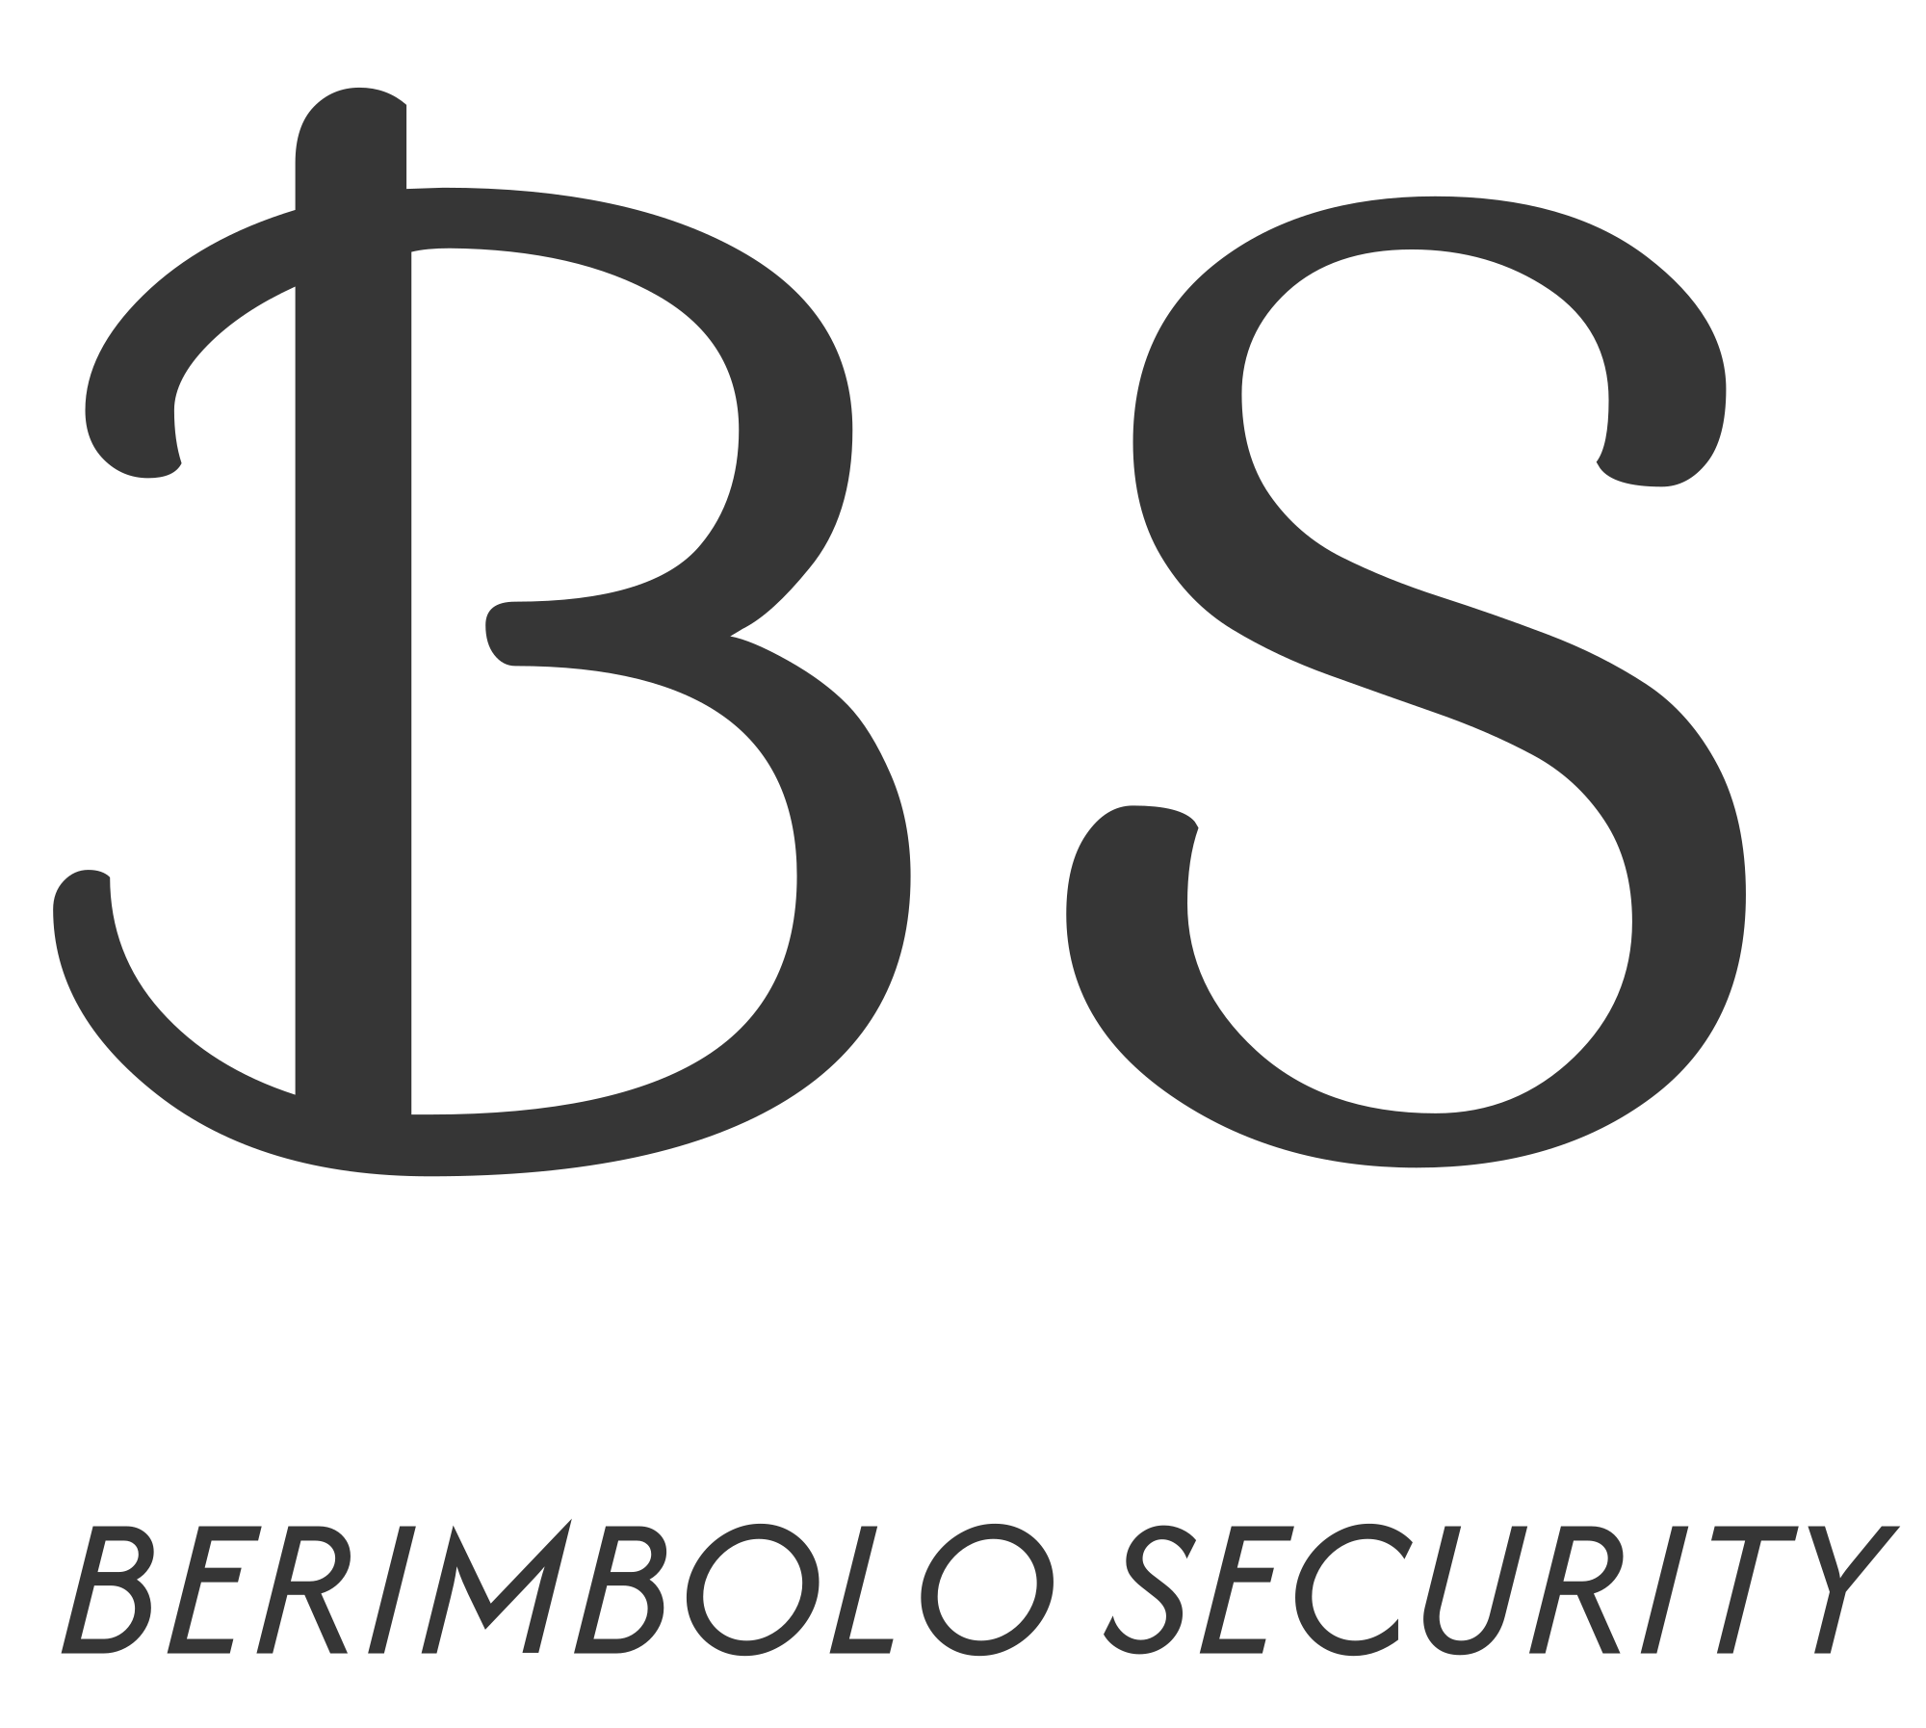

**Design**

User Interface (UI) Design: The design reflects a strong corporate identity using consistent colors such as blue and gray, enhancing a sense of trust and security. The content is easy to understand. Custom graphics and icons were used to emphasize the security character, such as CCTV images.

User Experience: Pages are organized in such a way that they can easily navigate between sections to guide the user. In addition, the design makes it easy for customers to send messages or request service via direct contact forms.

Responsive: works seamlessly on all devices, clearly without compromising on quality.

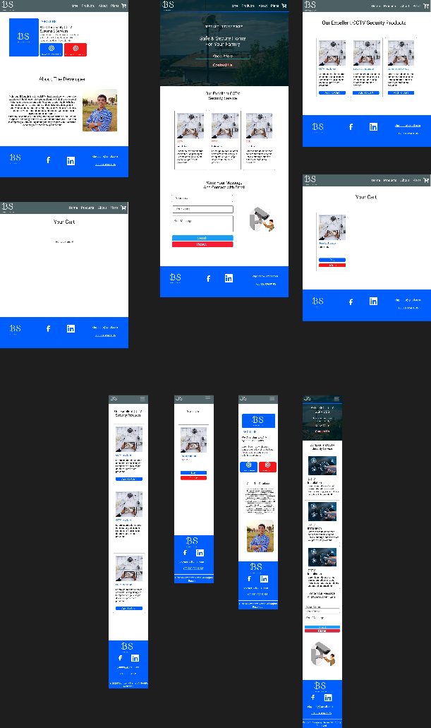Security and trust: The design enhances customers' sense of security by including logos and symbols that indicate reliability while providing clear information about the company and services.

**Sharing & Feedback**

Some of what I finished designing, I presented and shared with experts in web development, UI & UX, and my colleagues, and I asked them the following:

* about the user experience and the clarity of the interface.
* Inquire about the initial impression of colors and layout.
* Check the ease of use on different devices.
* Do you think that colors help show the security nature of the site?
* Can you easily find the contact form?

**Points that need improvement:**

1. **Coordination of color tones.**
2. **Add a form to communicate via email.**
3. **Content format.**

**Positive points:**

1. **Display the products beautifully and clearly**
2. **High-quality images.**
3. **Colors help show the security nature.**
4. **UX**
5. **Responsive**

**Identifying improvements & applying it**

1. **Add a form to communicate via email.**

Add a form that enables the user to communicate better with the company via email

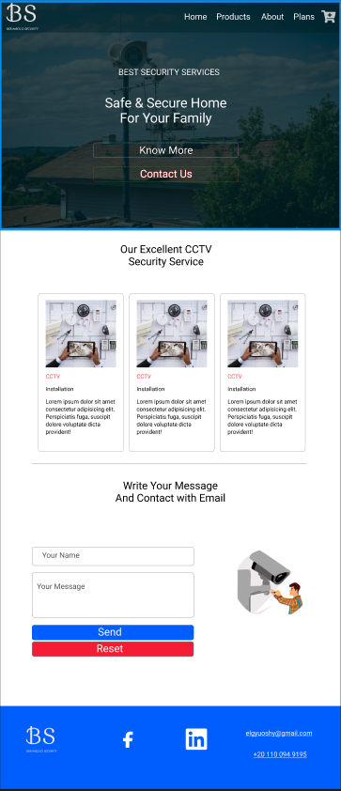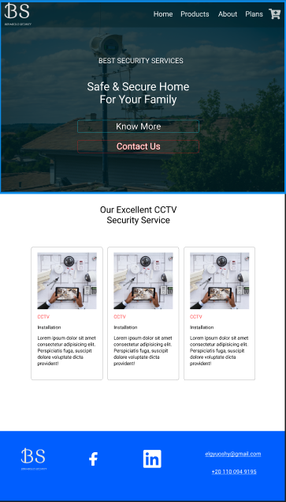**Before: After:**

1. **Coordination of color tones**

One of the most important points on which there were many comments is unifying the color pattern and not deviating from the specified wording, for example in button:

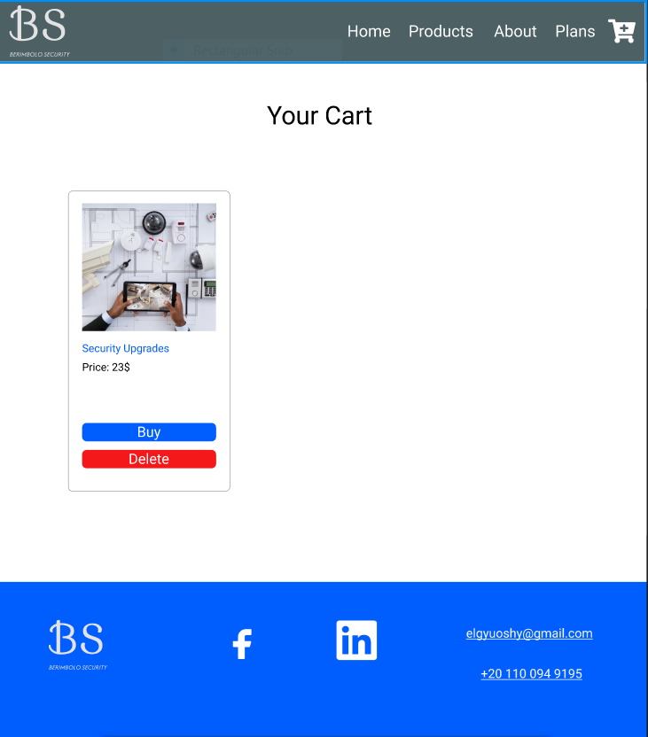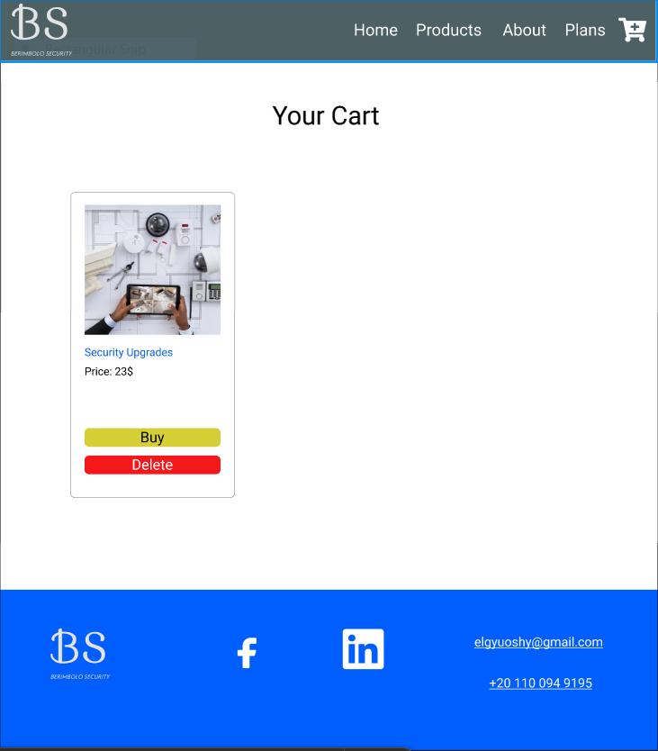Before: After:

1. **Content format.**

Improving the distribution of speech and images to make the user experience better and more comfortable.

Before: After:

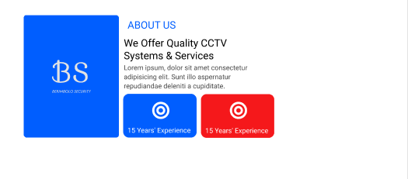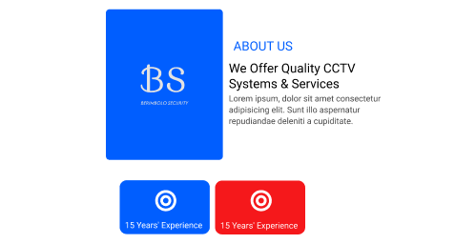

**Documentation**

1. **How do designs meet user needs and fit for purpose?**

It provides surveillance camera systems services in a clear and organized manner.

The design provides a simple structure that is easy to navigate, making access to information about products and services easy. The inclusion of sections such as "shopping cart" and contact forms provides a comfortable user experience. Including an image "about the developer" with text that highlights its background gives a sense of professionalism and transparency.

The design is responsive, showing the right shape for mobile and computers, meeting the needs of different users.

1. **Consider alternative options and justifications for final exams.**

Instead of static images, videos or animations can be added to promote services. More modern fonts can be used to attract more attention. Blue may attract users, but other colors such as orange or green can be added to add energy to the design.

1. **Why were the current options chosen?**

Stick to a simple design aimed at making the site user-friendly for non-technical users.

Blue expresses reliability and security and is suitable for a company that provides security services. Text and fonts are clear and easy to read on all devices.

1. **Proposed changes and what has been implemented:**

Adding a contact form: It was implemented to meet users' need for quick communication with the company.

Improved Products Section: Products were displayed with an “Add to Cart” option.

Provide responsive design: A mobile version has been implemented to maintain accessibility.

**Conclusion**

After successfully executing all the project points, a website has been designed that reflects Berimbolo Security's professionalism and enhances its digital presence. The new website contributes to achieving the company's goals by providing an outstanding user experience, providing clear information about services and products, and facilitating communication with customers.

The website is designed based on best practices derived from the analysis of competing sites, taking into account compatibility with various devices and screens. User and stakeholder feedback and recommendations were also applied to improve the design and increase its efficiency.

This website contributes to enhancing customer confidence in the services provided by the company, increasing access to new categories of customers while providing a modern and professional interface that keeps pace with the aspirations of the growing market.

